**Easy Lift**

**Dynamics 365 Business Central**

**Functional Requirement & Technical Design Document**

**Table Of Content**

1. Easy Lift’s Sales Process……………………………………………………………………………………. 3
2. Possibilities in Business Central………………………………………………………………………….3
3. Gaps & Solution………………………………………………………………………………………………….4
4. Technical Changes………………………………………………………………………………………………4
5. BC Sales Flow………………………………………………………………………………………………………5
6. Sign Off……………………………………………………………………………………………………………….9

Project Key Contacts

|  |  |  |
| --- | --- | --- |
| **RelateIt** | **Name** | **Email** |
| Project Lead | Aron Rohden | arh@relateit.com |
| Team Lead | Iheb Mahmoudi | ima@relateit.com |
| Developer | Nikhil Singh | niksingh123@gmail.com |

**Easy Lift’s Business Process**

EasyLift is a company that specializes in elevator maintenance in tall buildings. Whenever EasyLift has serviced an elevator, they will sign a Certificate and leave it in the elevator unit. Each Certificate has a unique id of 20 characters which is used to identify the specific time and job carried out on the elevator. EasyLift always presents their customers with a formal quote specifying the job and its price. If the quote is accepted, it will then be made into an Order and later invoiced when the job is done.

**Requirement 1:**

EasyLift wishes for their Certificate Reference to be recorded on the Sales Order. When the invoice Is posted, the Certificate Reference must be carried over to the posted document and it must be displayed on the Sales Invoice (report) sent to the customer. It must not be possible to post an invoice if the Certificate Reference is not filled out.

**Requirement 2:**

As a part of becoming a paperless company they want the certificate PDF file to be attached to the Sales Order. When the Sales Order is posted the attached file should be carried over to the posted invoice and it should be possible to access it there.

**Requirement 3:**

EasyLifts management has decided to invest in a Business Intelligence initiative in the company. To this end they need the Certificate number to be associated with the General Ledger Entries to gain insight into every service job they perform.

**Possibilities in Business Central Standard**

In Standard Business Central, Sales Quotes can be used to send a formal quotation to the customer with the customized field Certificate Reference number entered manually and after approval from the Customer, the Quote can be converted into an Order using “Make Order" functionality.

After converting Quote into Order the field will flow to Order and the Order can be invoiced by posting the Sales Order and the Certificate Reference will flow to the Posted invoice as well as to the G/L Entries. The error message can be shown on posting if the Certificate Reference is not filled.

The Certificate PDF document can be attached to the Sales Order using the standard BC functionality of Attachments the document will flow to the posted documents and it can be found in the Invoices under the Attachment fact box.

**Gaps & Solution**

1. A new field needs to be added on Sales Header “Certificate Reference” of type Code[20] which will be manually entered from Sales Quotes
2. The field also needs to be added in other posted tables of Sales i.e Sales Invoice Header, Sales Shipment Header, Sales Cr. Memo Header
3. Error on Posting if the Certificate Reference is not filled in
4. Certificate number must be shown on posted G/L Entries for reporting purposes
5. Show the Certificate Reference on the Standard Sales Invoice Report

**Technical Design Changes**

1. Created table extensions and add the Field “Certificate Reference” type Code[20] on Sales Header, Sales shipment Header, Sales Invoice Header and Sales. Cr. Memo Header table.

Kept the field ID same in all the tables so that it flows to all posted tables without any additional code.

1. Created Page Extensions and the field on Sales Quote, Sales Order, Posted Sales Invoice and Shipment pages.
2. Created a Codeunit “Sales Events Mgmnt” and subscribe to the existing events and check before posting the sales document if the Certificate Reference field is empty.
3. Created a report extension extending “Standard – Sales Invoice” add the newly added field in the report extension and add the field in word layout to display it in the report.
4. Added field “Certificate Reference” type Code[20] in Gen. Journal Line and G/L Entry table
5. Used “Sales Events Mgmnt” and subscribe to the standard events from Codeunit 12 Gen. Jnl Post-Line to flow “Certificate Reference” to G/L Entries

**Business Central System flow as per the requirement**

Create a Sales Quote and add the “Certificate Reference” number. Print and send the formal quotation to the customer.

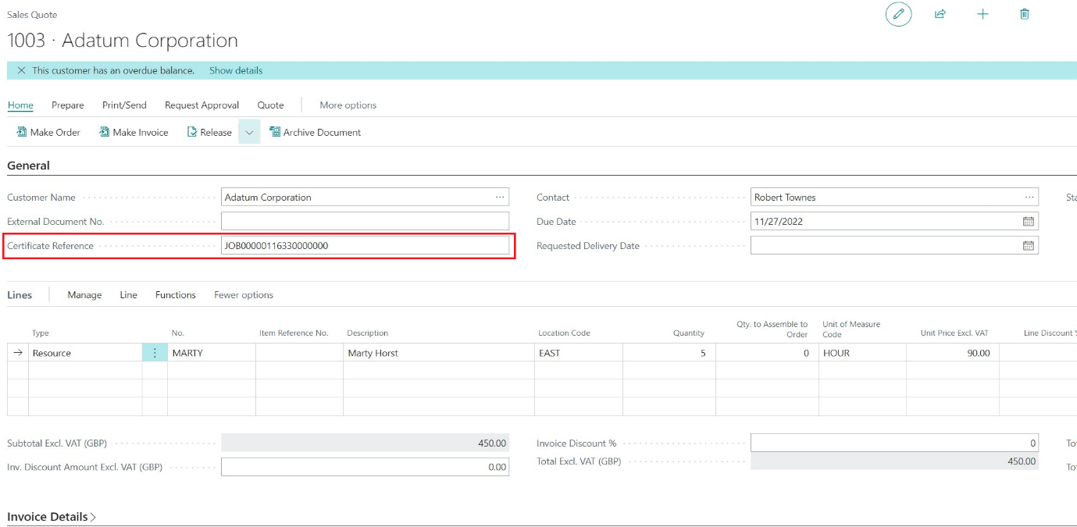

Use the Action “Make Order” to convert the Quote to Order. The “Certificate Reference” will be tagged in the converted order

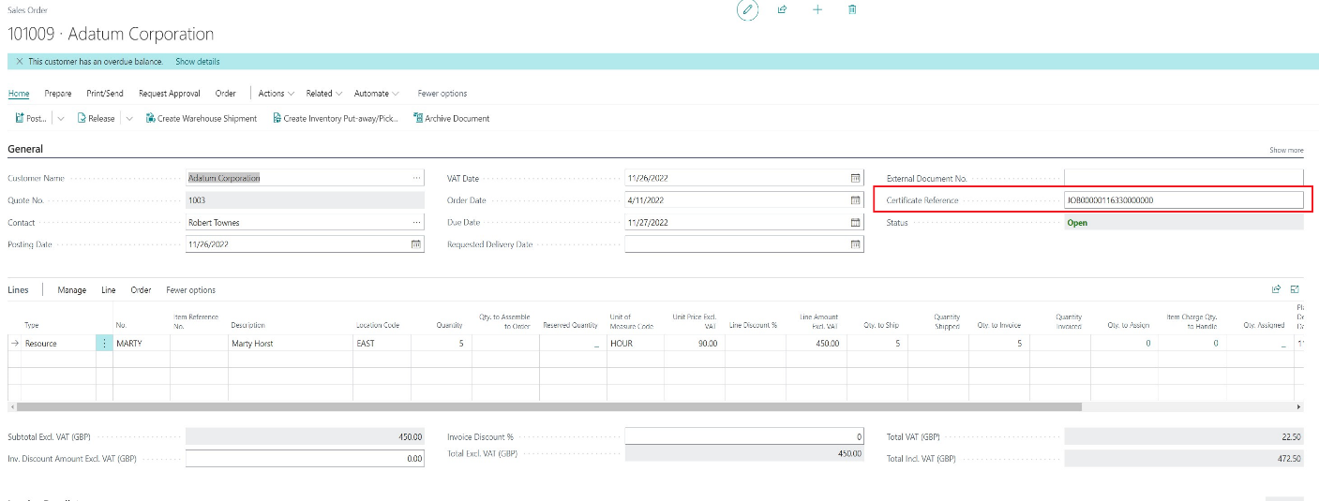

On the right side of Sales Order page there is the option to Attach the Certificate pdf document on the Sales Order

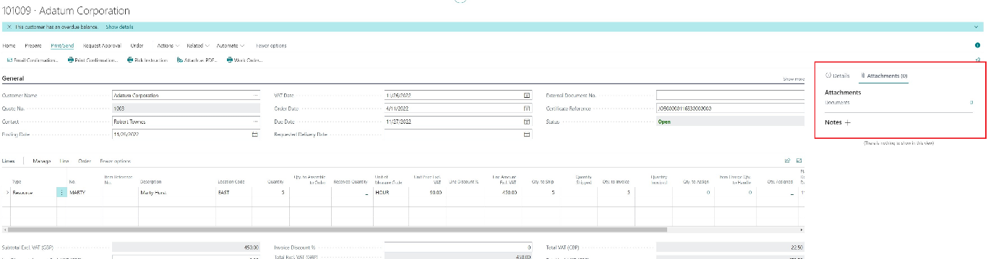

Add the document by clicking on the number of documents. Currently, as no documents were attached it shows 0. After clicking on the number the system will open the dialog as shown below

Click on “Attach Files” and add the Certificate document pdf by browsing to the saved location

The document will be attached with details of the Attached date and time as well as the User ID

Post the Sales Order. If the Certificate Reference is empty then the below error will be shown and the system will not allow to Post the Sales Order.

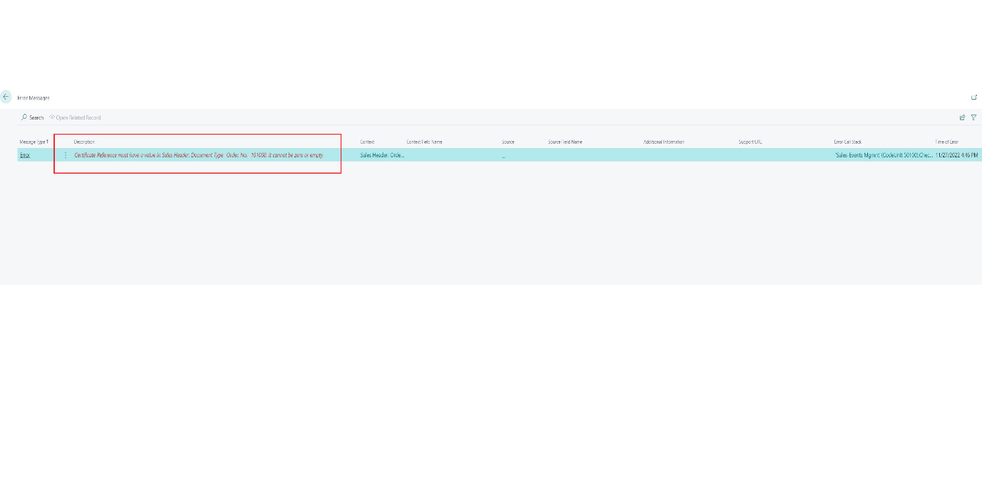

Search for the relevant Posted Invoice and check the attachment tab. The attached document will be accessible in the invoice as well. Also the “Certificate Reference” number will be visible on the Posted Sales Documents.

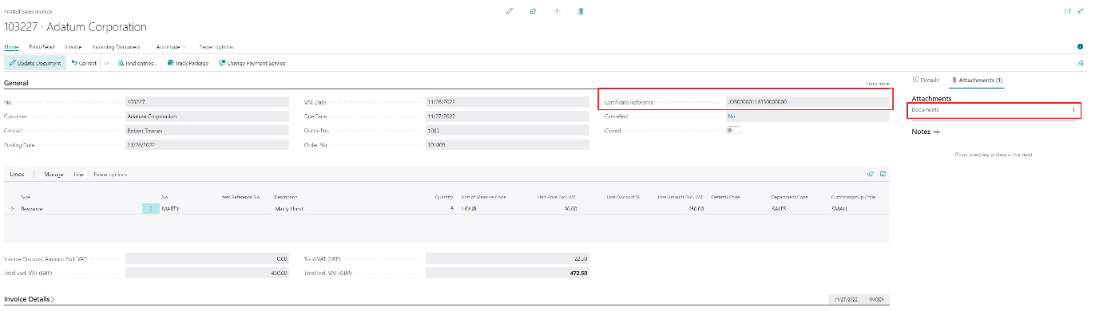

Navigate to “Find Entries” action and check the G/L Entries of the posted document. The “Certificate Reference” will be available on the G/L Entries as well.

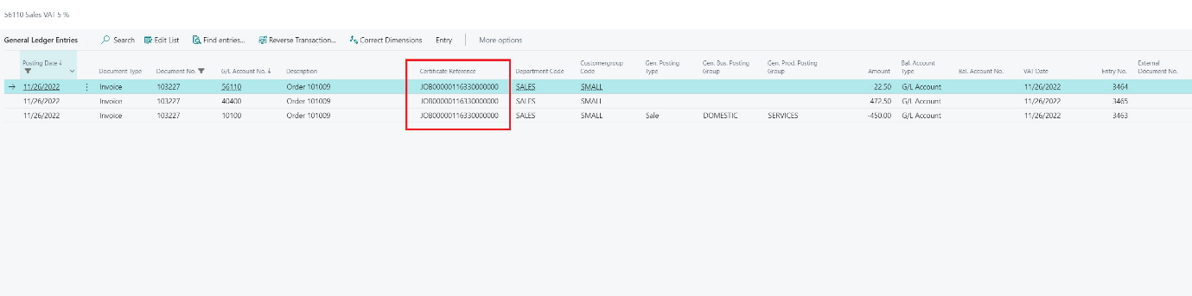

The Sales Invoice will also display the newly added field as show below

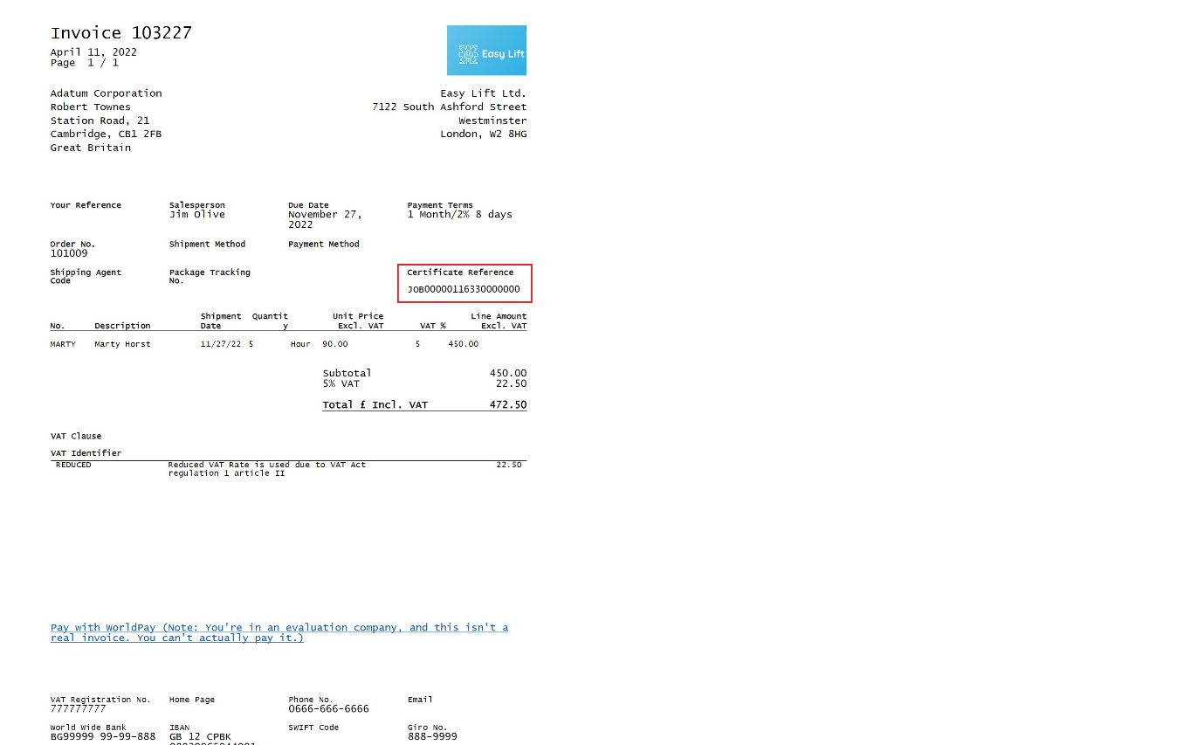

Sign Off

|  |  |
| --- | --- |
| Project: | Assessment and Analysis |
| Customer: | Easy Lift |
| Reference: | Functional Requirements and Technical Design Document |
| Revision | 01 |
| Date: | 27.11.2022 |
| Requested by: |  |
| Reviewed by: |  |
| Issued by: | Aron Rohden |